1.1 Student name levi Delaney 2021304

my project is based on the battle bots series and aims to provide a similar event for new zealanders

1.2 conceptual design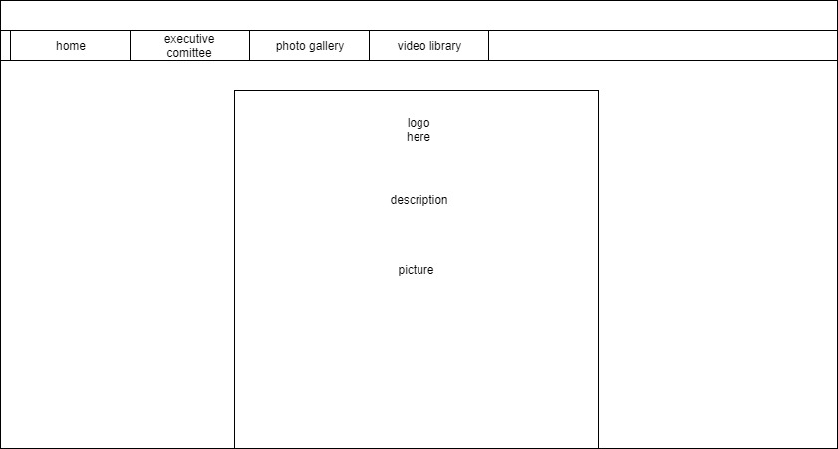

Testing

The main thing that i had to test in my website was the nav bar to ensire that the items linked up to the right pages. One of the links was not working to i had to find where it wasnt working and change the code so that i properly linked to my other page

I also had to ensure that the current page colour was showing for the right page in the nav as well i had this issue when i made a new page then copied the code over, which made the page display the current colour on the wrong page. To fix this i changed the class to active on the correct list item

1.3

a 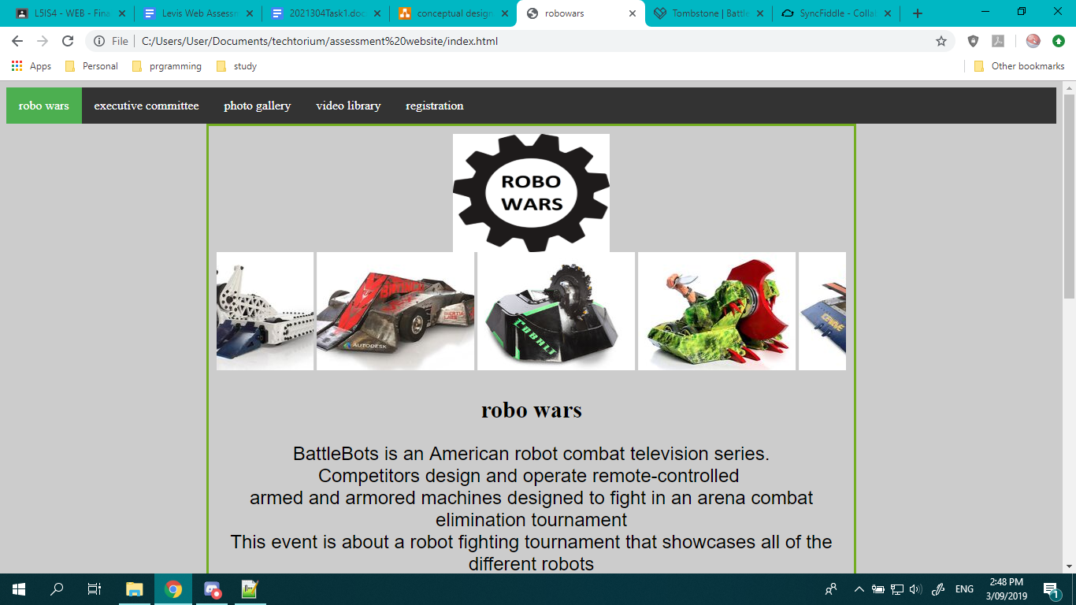

This page is an introduction page and it helps educate the user about the different robots in the competition

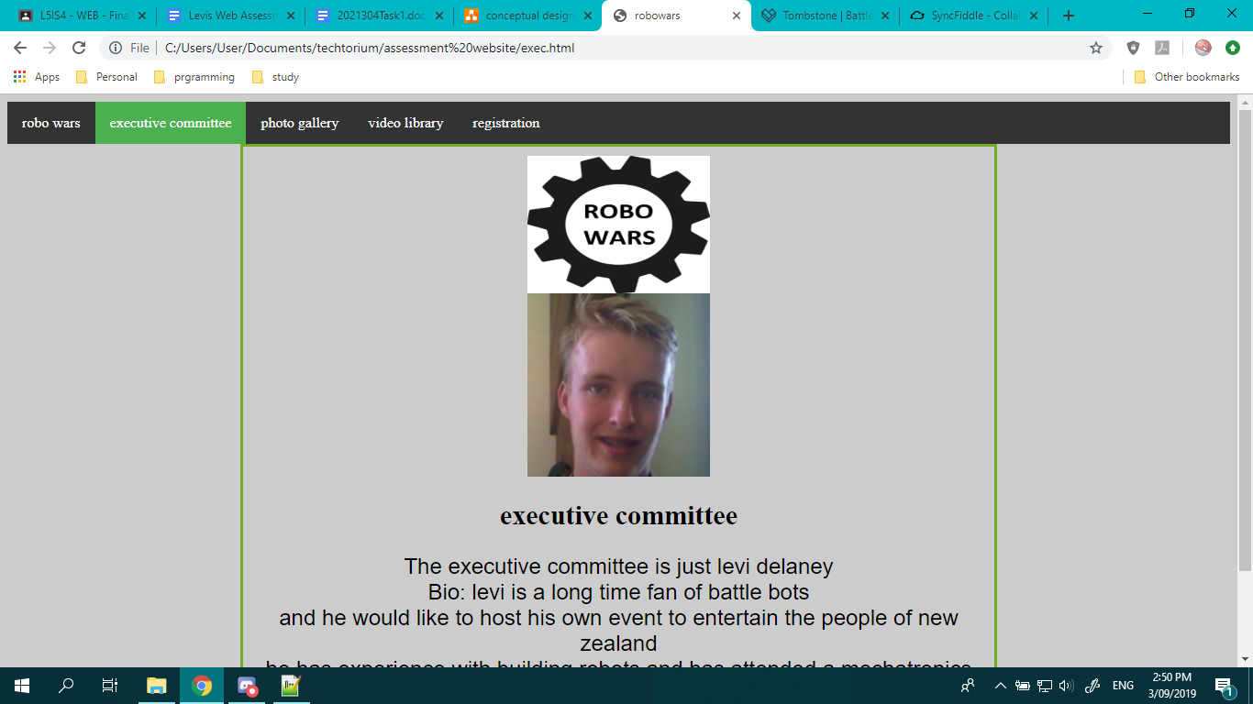

This page tells the user about the executive committee and a bit of information about the member

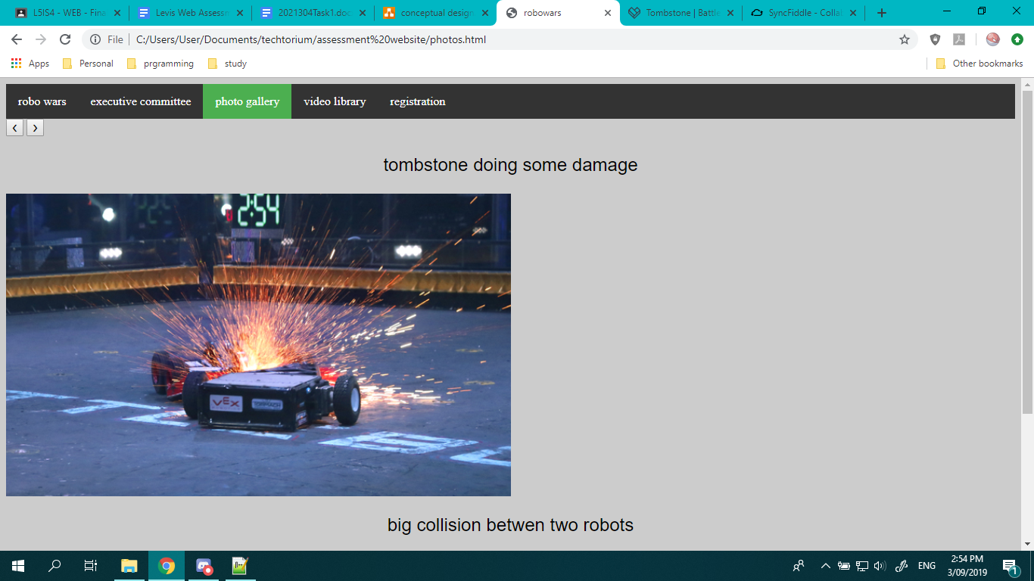

This page above shows what usually happens in the arena and what to expect in the upcoming event

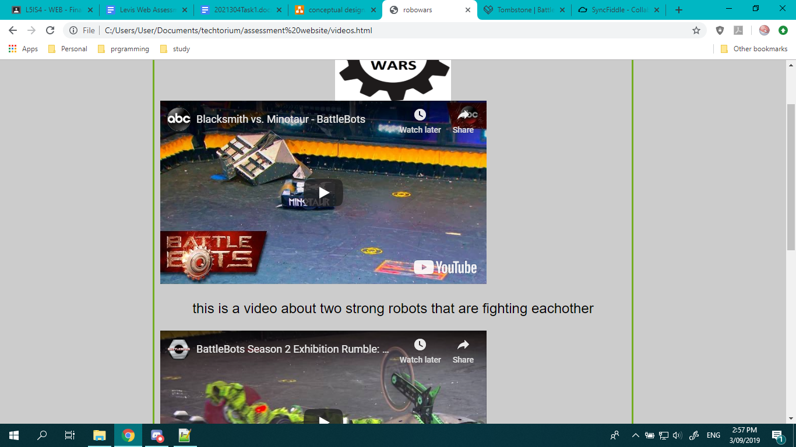

This shows videos of past robo wars battles every video is only a few minutes long as to make the person want to see more and sign up to the event

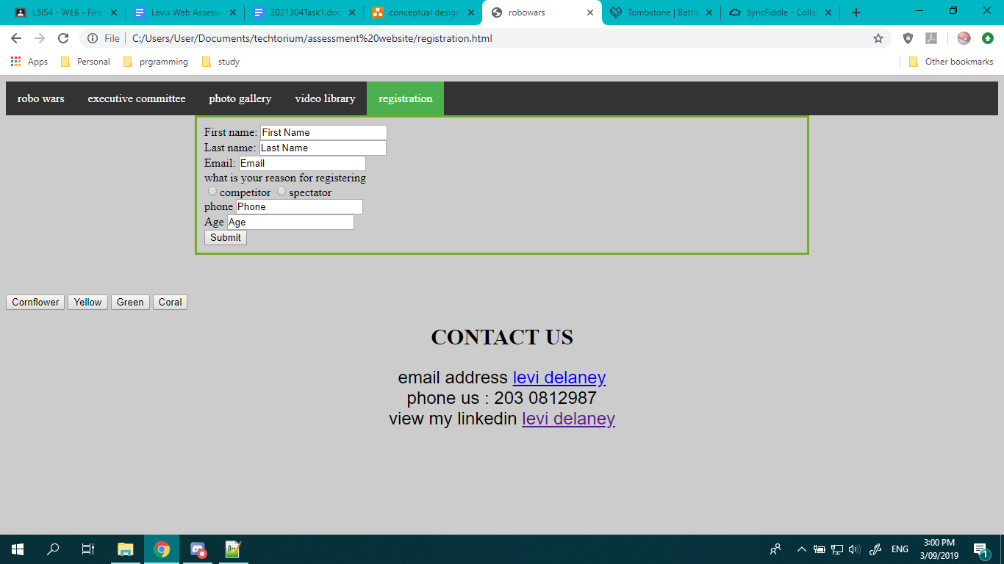

Lets the user register for the event

Also lets the user contact me via email or by phone and can see my linkedin profile

Screen shot of my web code

